Programming Statement LAB-3

Name: Kaushik Parmar

ID: AF0448761

1. 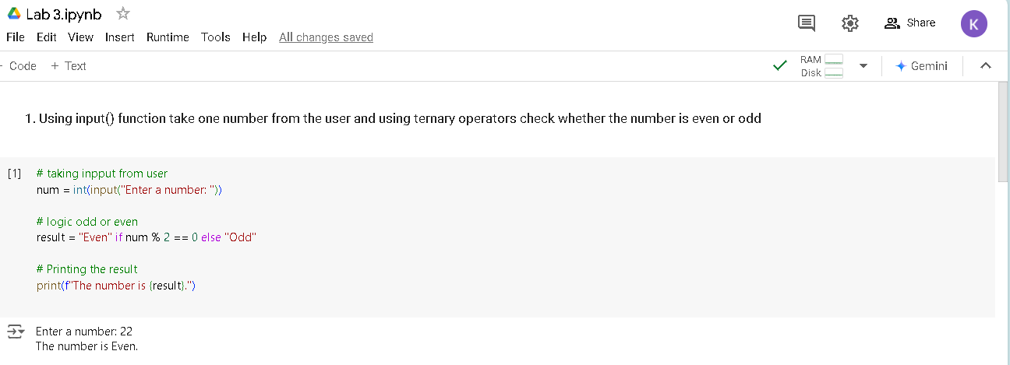Using input() function take one number from the user and using ternary operators check whether the number is even or odd
2. 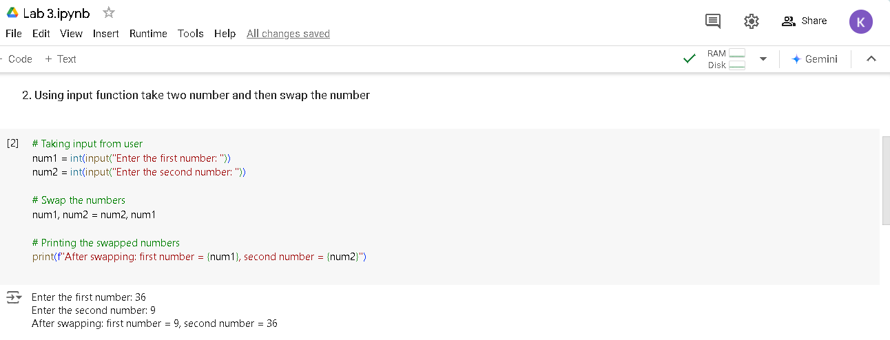Using input function take two number and then swap the number.
3. 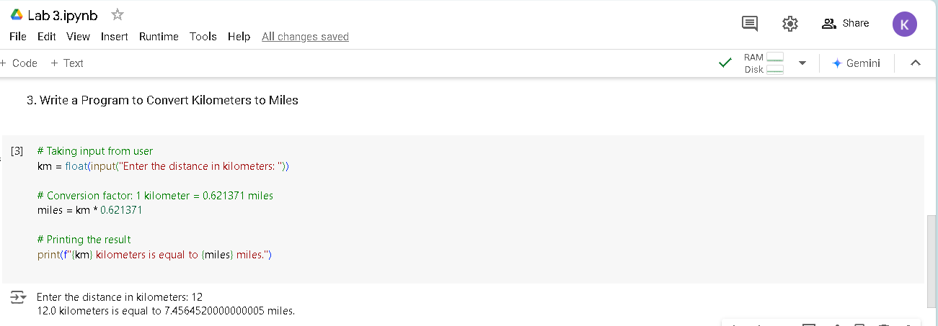Write a Program to Convert Kilometers to Miles.

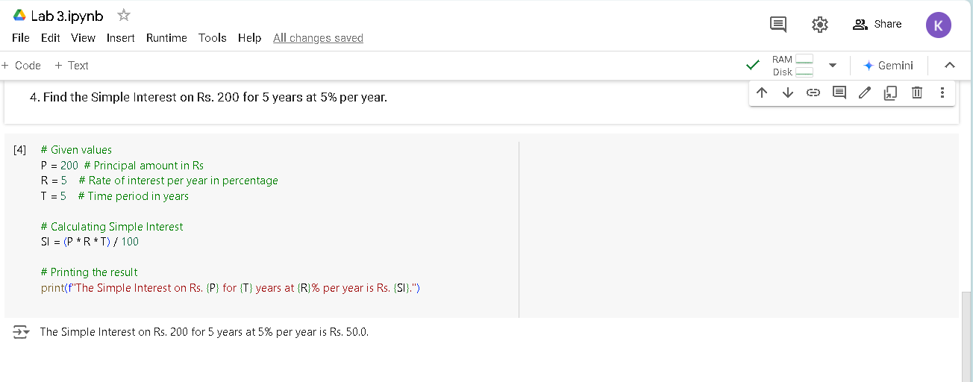4. Find the Simple Interest on Rs. 200 for 5 years at 5% per year